Economics “Theme” OpenScholar Sites for Graduate Students

This purpose of this document is to help Economics Department graduate students create “standard” econ OpenScholar sites. An example of how this standard looks is here:

http://scholar.harvard.edu/jmollers

If at any point, you need help with OpenScholar sites, please feel free to contact user support:

ithelp@harvard.edu

If you need additional help, please don’t hesitate to contact me at pbrown@harvard.edu

First, Create Your OpenScholar Site

Browse to http://scholar.harvard.edu/site/register, log in with your PIN, and fill out the form.

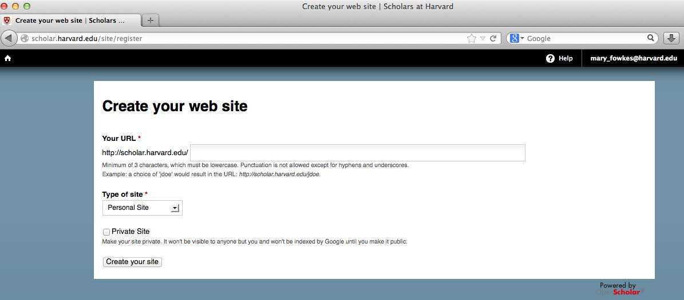

(These site-creation pages might look a little different from when I created my site, but the procedure for doing this should be similar.) If you choose to make your site private while you are creating it, remember to make it public again when the site is ready.
Now you may log in by clicking Go there now.

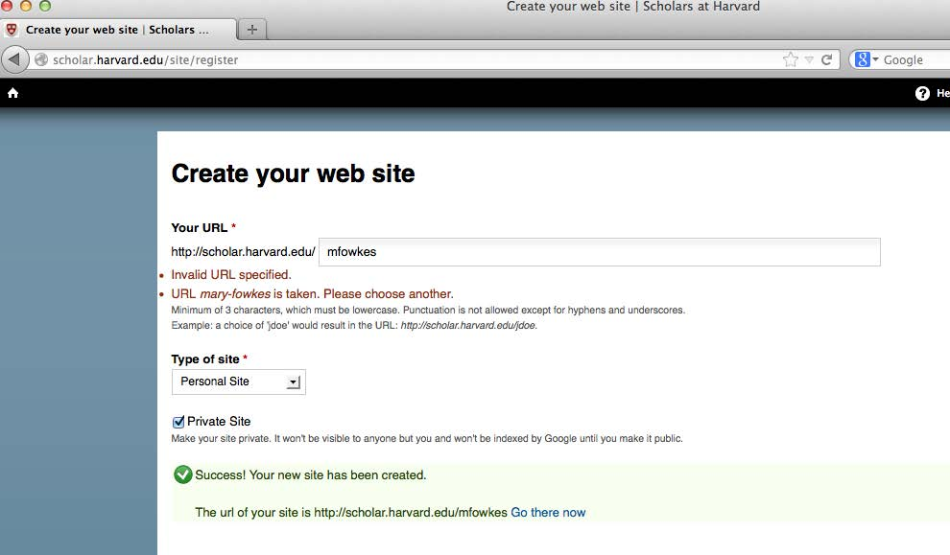

Change theme to Classic

After logging in, choose APPEARANCE

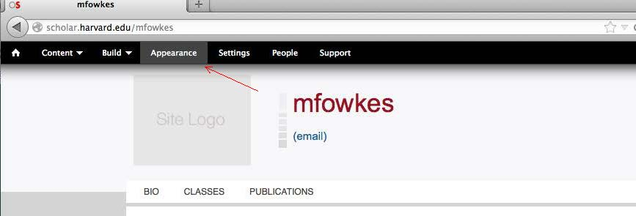

Select HWPI Classic Theme. You may have to look around on this page to find the HWPI Classic Theme.

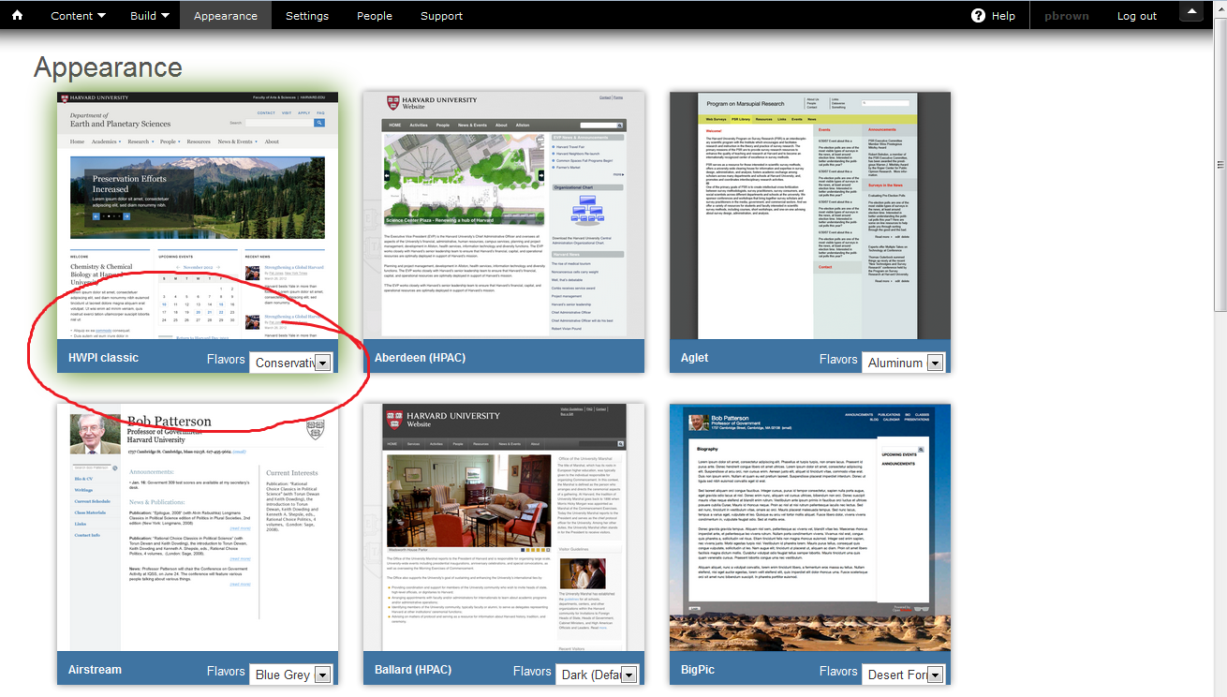

For Flavor, select the default, which is “Conservative.” Remember to click SAVE CONFIGURATION at the bottom of the page.

Apply Standard Econ Settings

Now go back to the black tool bar across the top and choose BUILD LAYOUT

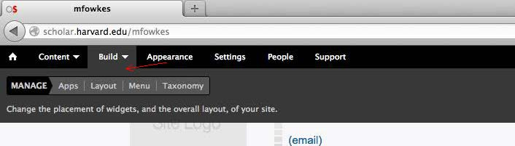

Under Layout/Site Selection, select All Sections

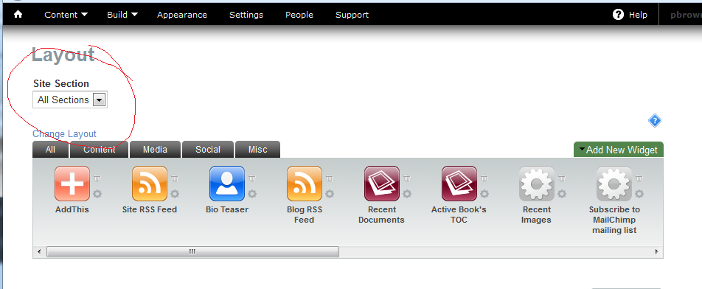

Edit Site Info

In the layout for All Sections, the SITE INFO widget should be left in the center top frame.

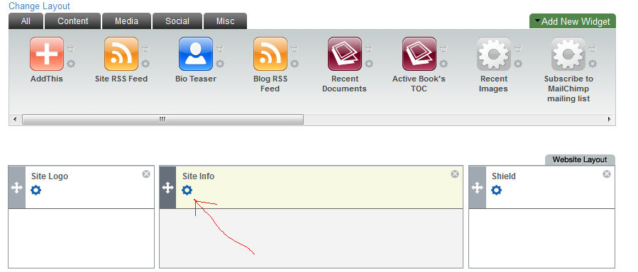

Click the little blue wheel to edit SITE INFO widget to personalize the info.
TITLE: John Harvard (for example)
DESCRIPTION: Ph.D. Candidate in Economics (for example)
Leave Address line blank.
Click SAVE.
After saving here, the editing window might not close automatically. If it doesn’t, close the window if necessary by clicking the big X in the upper-right hand corner (this seems to depend on which browser you are using).

Remove or Relocate Widgets

To get rid of widgets that don’t fit the standard layout, you would click the little X in the upper-right corner of each non-econ widget. This moves them up the gray Widget Selection Panel across the top of the layout section. If you accidentally remove the wrong one, you can drag it back down into your layout.

Remove SITE LOGO widget
Remove SHIELD widget
Drag the PRIMARY MENU widget down to the horizontal layout column on the left side.
Click Save at the bottom.

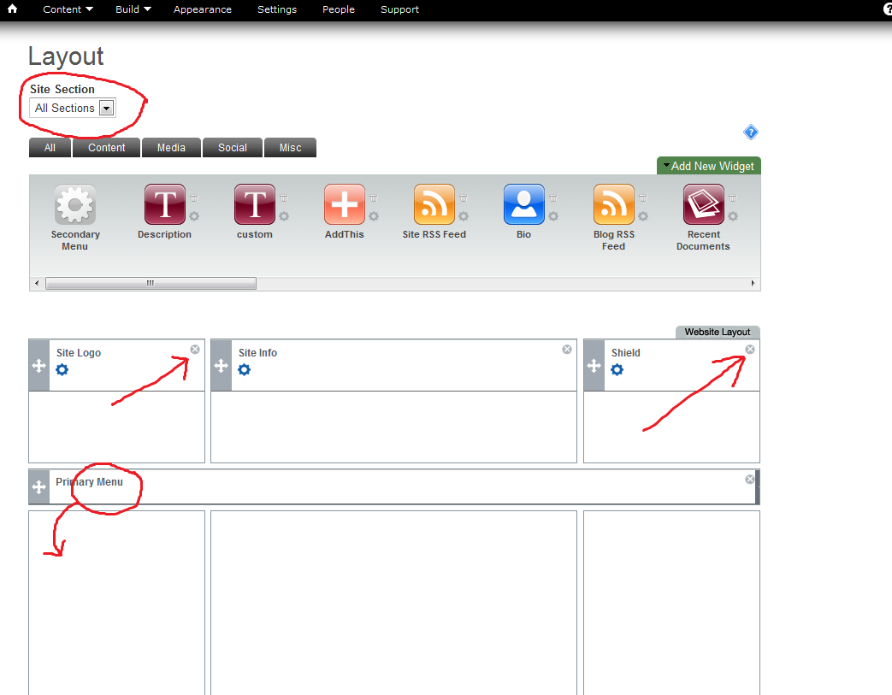

So Far the Layout Should Look Like This:

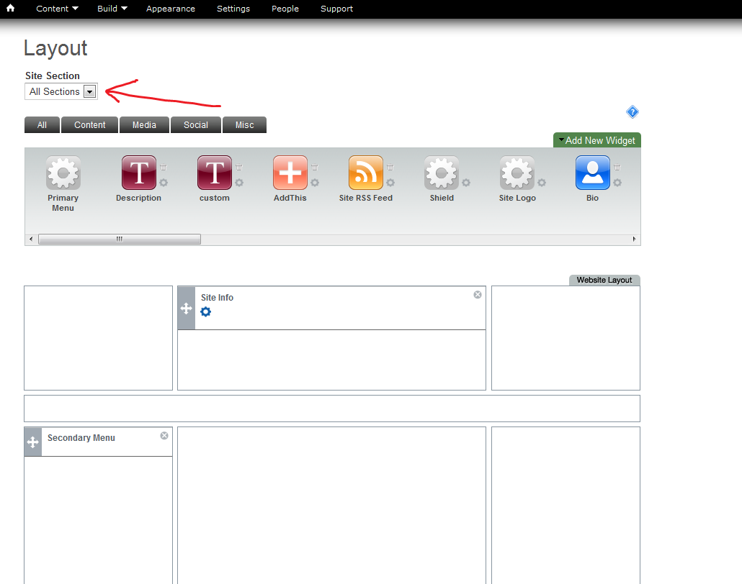

Create Economics Affiliation Widget
Click “Add New Widget”
Select “Custom Text/HTML”

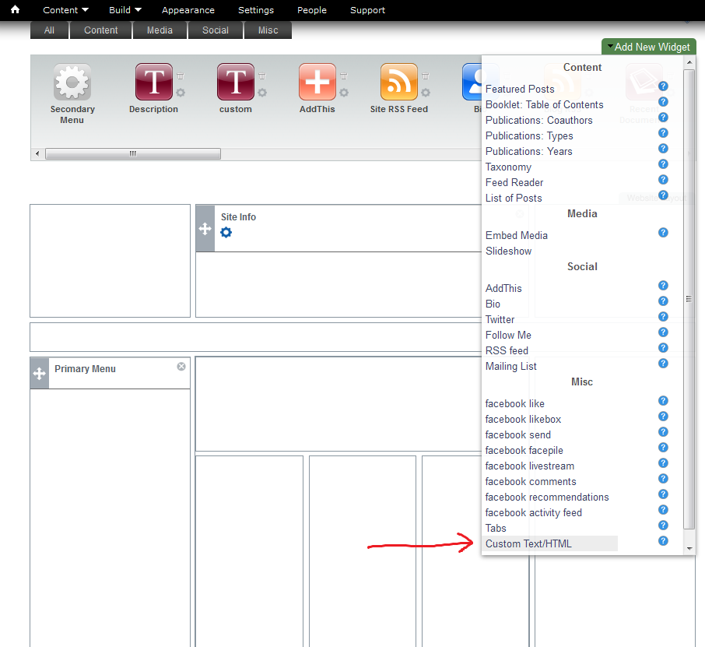

When You Create the Affiliation Widget:

WIDGET DESCRIPTION: Affiliation Module
WIDGET TITLE: Leave Blank
Click inside CONTENT block
Click Add Media.

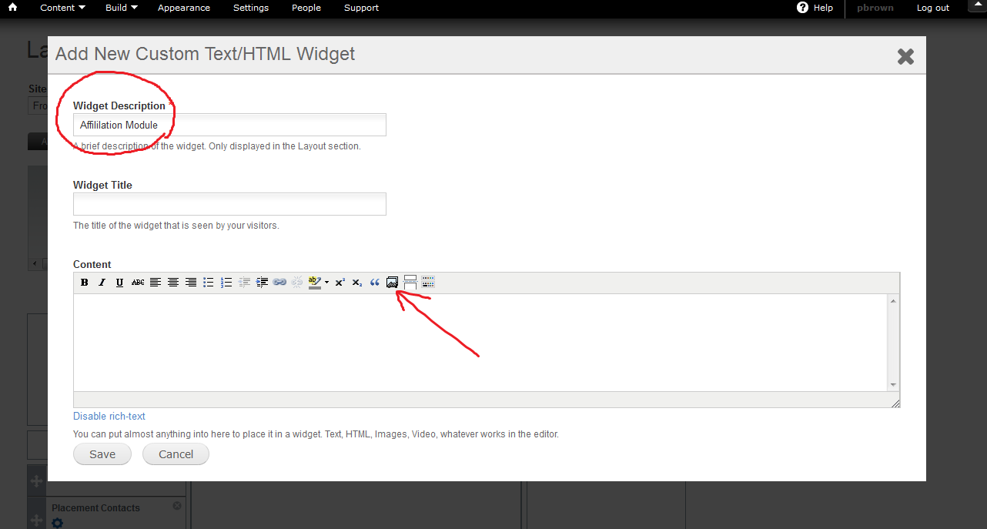

Browse for and SELECT EconLogo.png wherever you put it on your computer (I’ve emailed this to you; let me know if you don’t have it.)

Once you’ve located and selected Econlogo.png, you can “submit” the image into the widget.
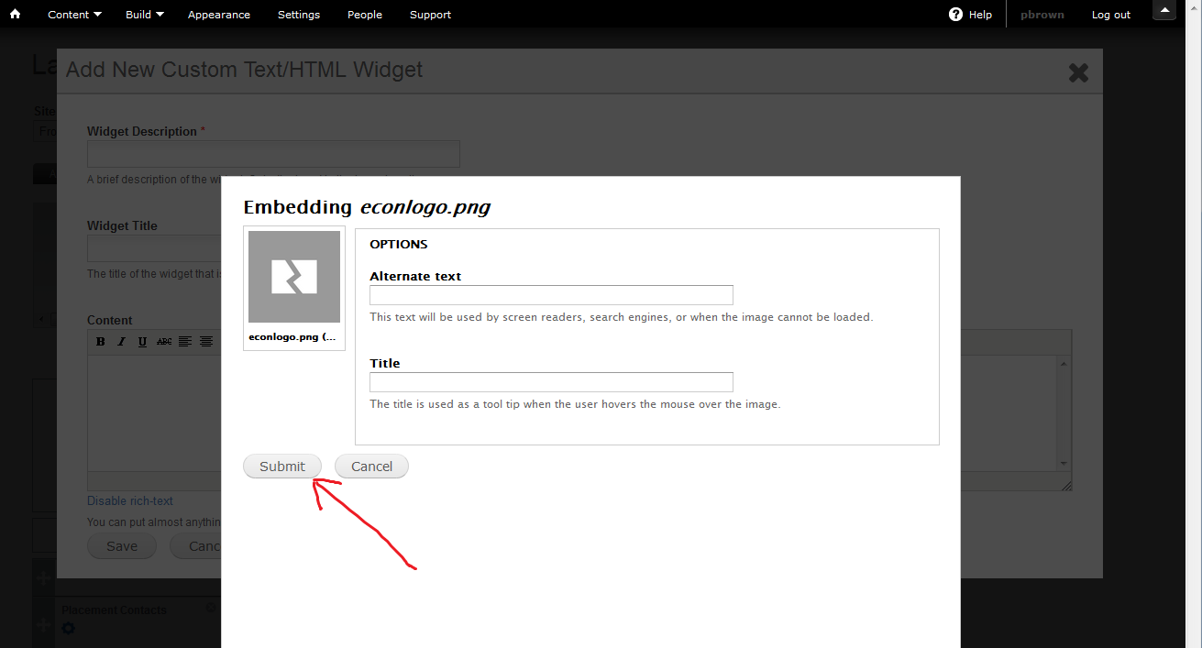

Don’t forget to SAVE.

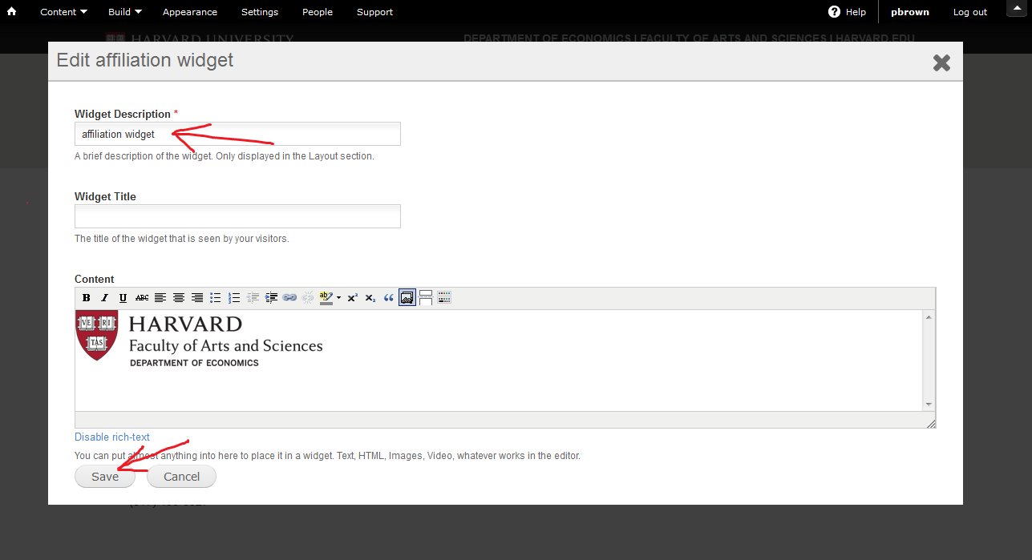

Place newly created Affiliation Module widget on FRONT PAGE
Go to BUILD LAYOUT and make sure FRONT PAGE is selected in Site Section. You should find the Affiliation Widget on the Widget Selection Panel.
Drag AFFILIATION MODULE to the Middle Column of the layout.

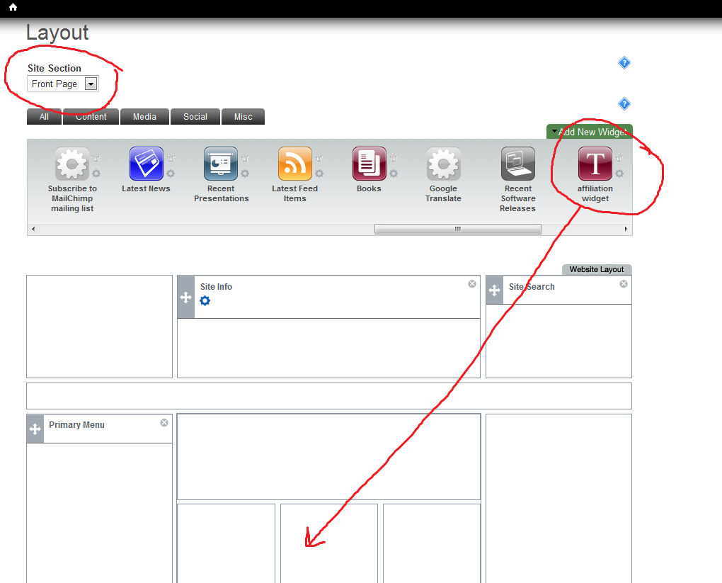

Create Contact-Info Widget

For creating the Contact Info Widget, you use a similar procedure as for creating the Affiliation Module, though you would:

1) give the widget a different name (contactinfo, for example),
2) type in or copy-and-paste in the contact info into the editor,
3) not need to upload or include any images.

Remember to click SAVE when you are done.

Create Advisors Widget

This is the same procedure as the Contact-Info widget, only requires different info.

Create Photo Widget

For creating the Photo Widget, you use a similar procedure as for creating the Affiliation Module, though you would:
1) select the Embed Media Option under Add New Widget (on the right side, above the Widget Selection Panel).

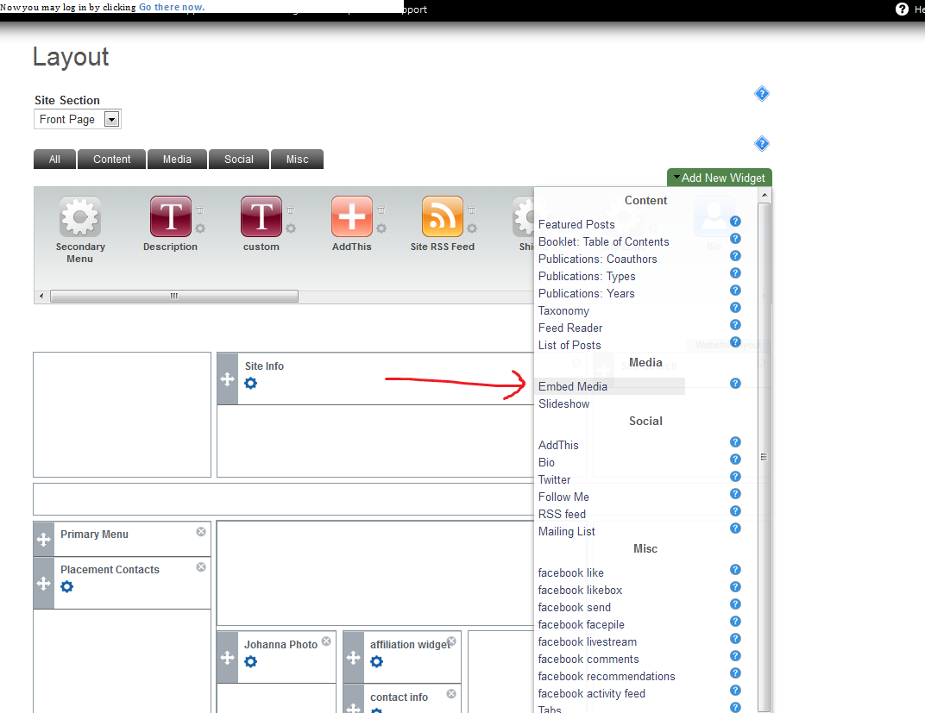

2) give the widget a different name (MyPhoto, for example).
3) upload your photo to the widget.
Remember to click SAVE when you are done.

Economics Standard Layout

Place the Affiliation Module above Contact Information. Below is an image of the Economics standard layout for the Front Page. You can move the widgets around by dragging and dropping.

This is how it should look:

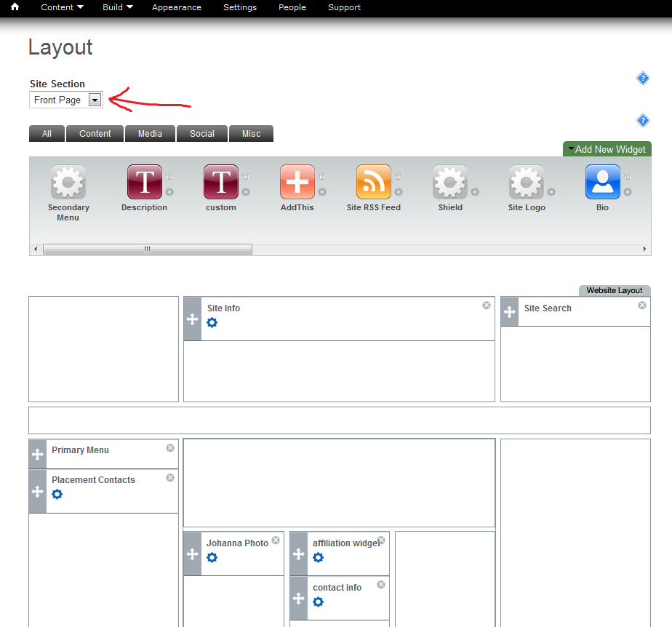

Don’t forget to click SAVE at the bottom.

Again, it may help to refer to an example of the econ-standard site:

http://scholar.harvard.edu/jmollers
Now, click on the home symbol in the upper–left corner of your site to see how things look:

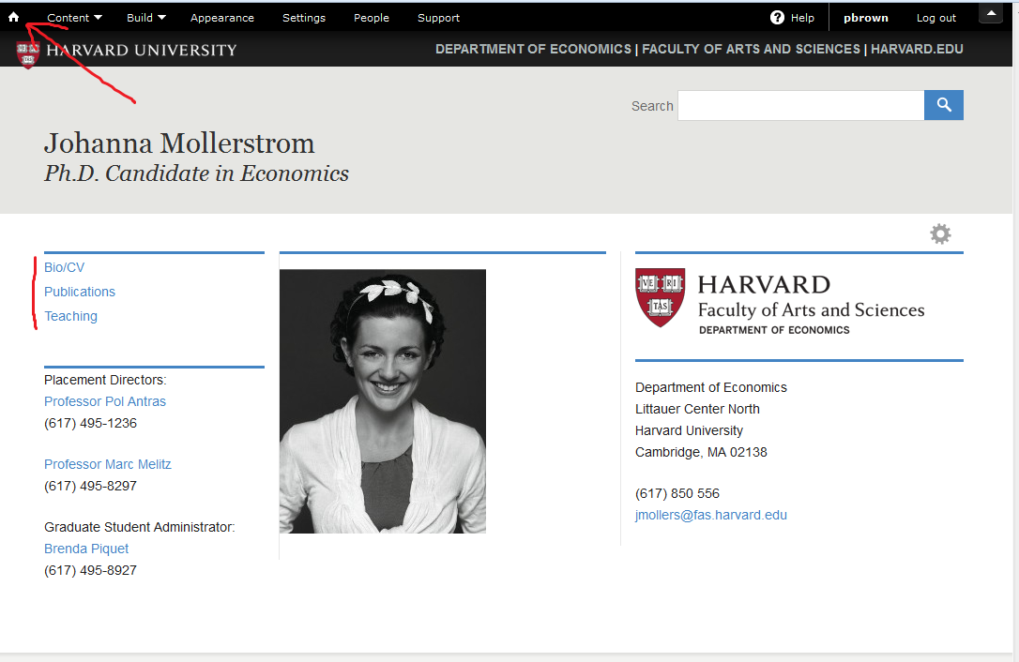

You could also click on the Bio, Publications, Classes (here shown as Teaching) subpages and begin uploading your academic materials.

To Make Your Site Public

Click Settings. Under Privacy, Site Visibility, click Public on the Web. Please let me know when you are ready to link your site to the Economics Dept. site.

Support

If you have any questions about creating your OpenScholar site, please write to:

ithelp@harvard.edu

If you need additional help, please don’t hesitate to contact me at pbrown@harvard.edu

